**Installation Scenarios: Final3**

**

**Splash Screen:**

**Copy right:**

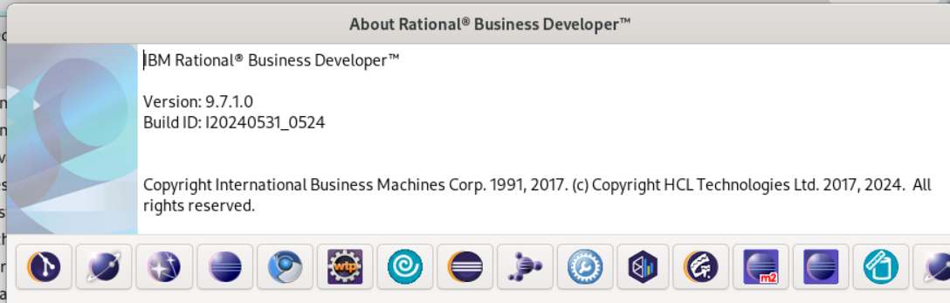

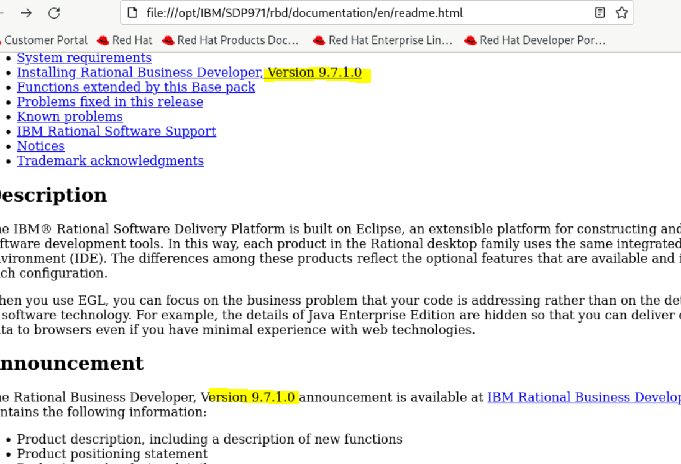

**What’s new**

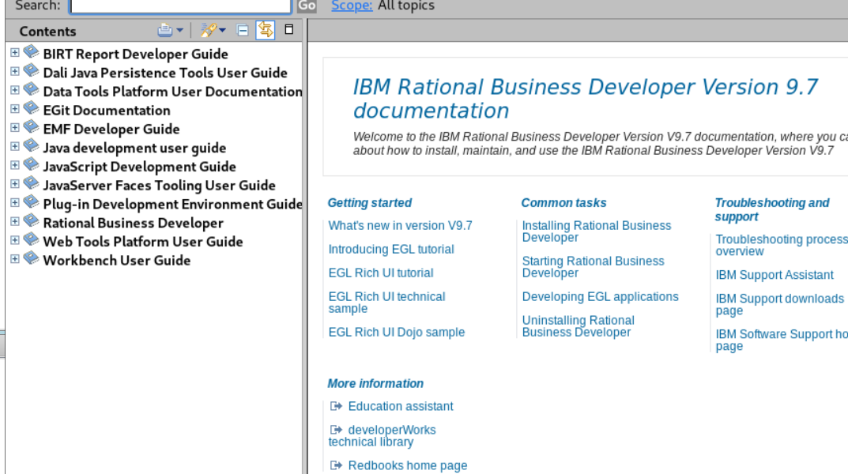

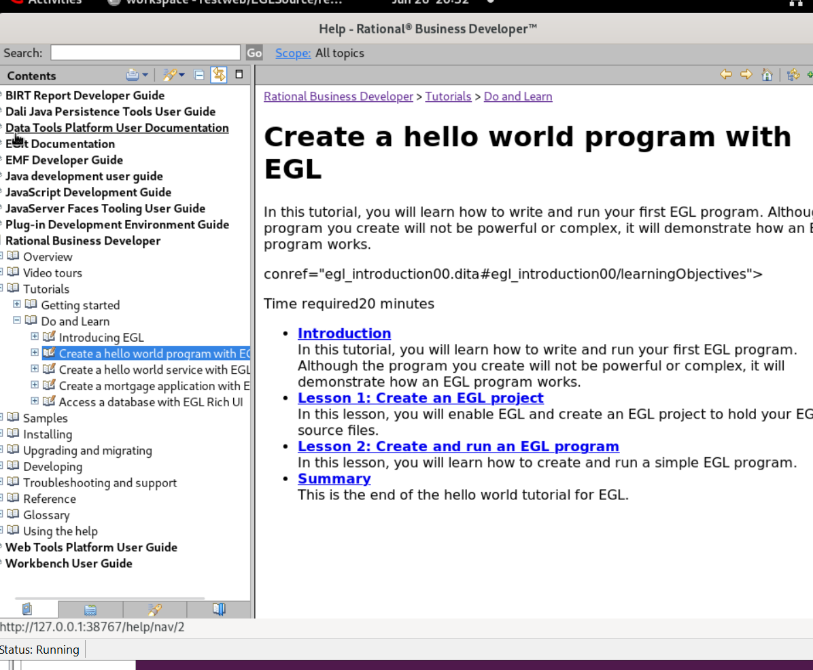

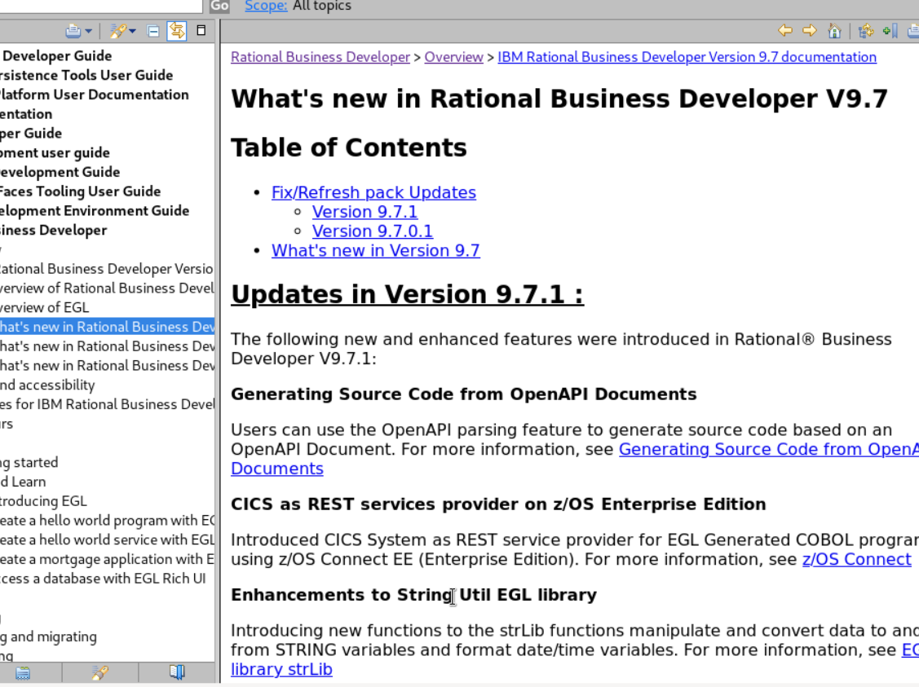

**Java Generation:**

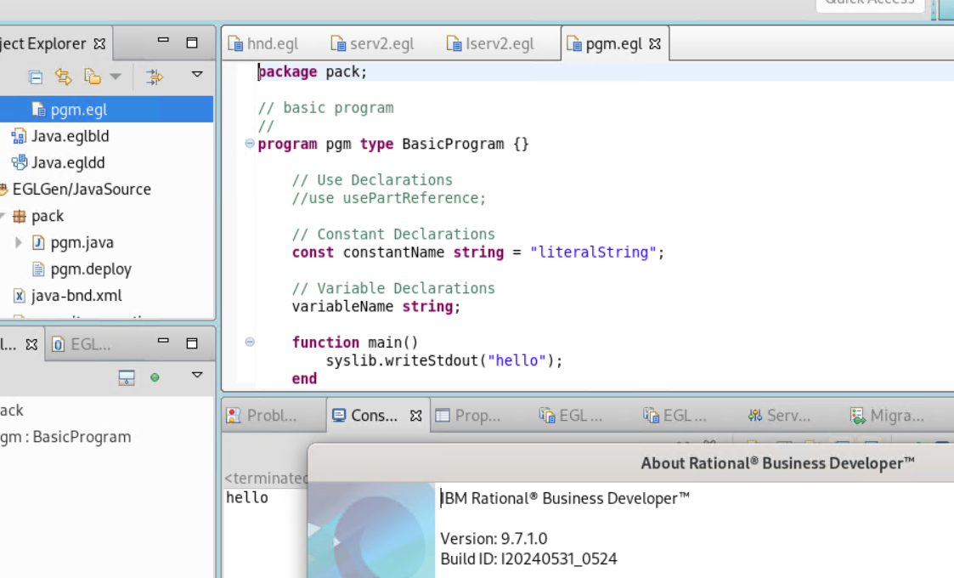

**App Servers and Browsers:**

**Browsers:**

Firefox Version: **115.12.0esr**

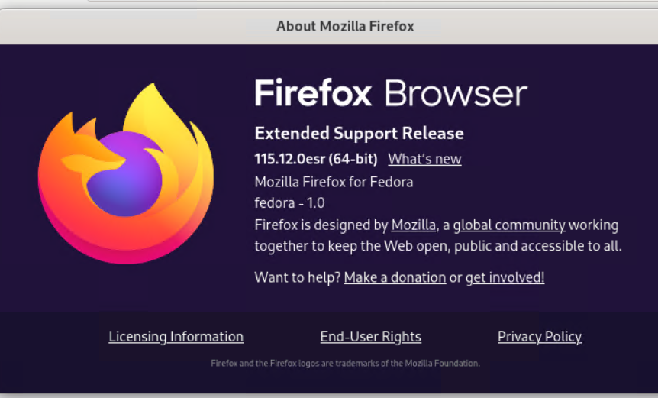

Edge Version: **126.02592.68**

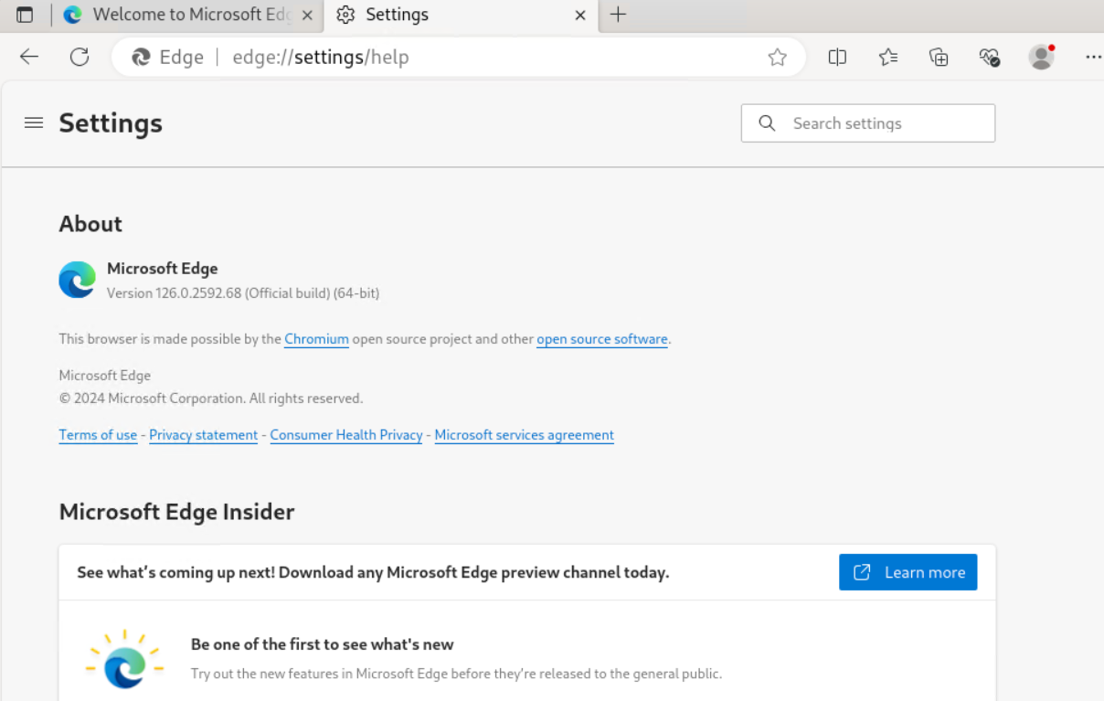

Chrome Version: **126.0.6478.126**

**App Servers:**

**

Rest Service Invocation:

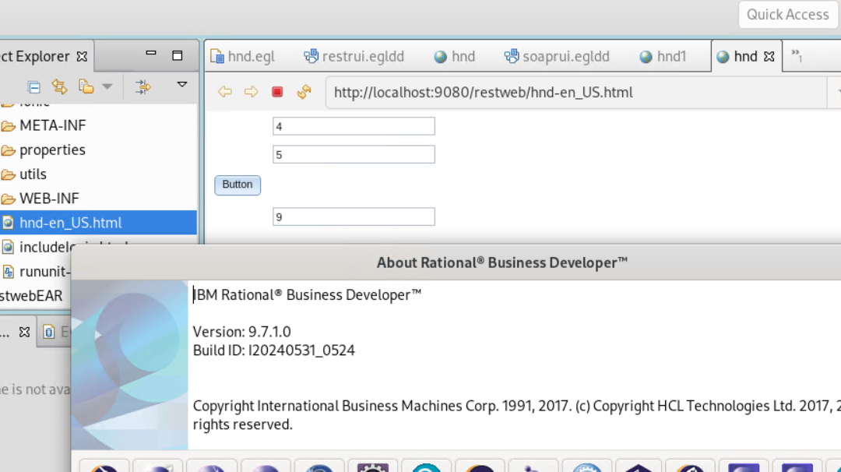

Soap Service Invocation:

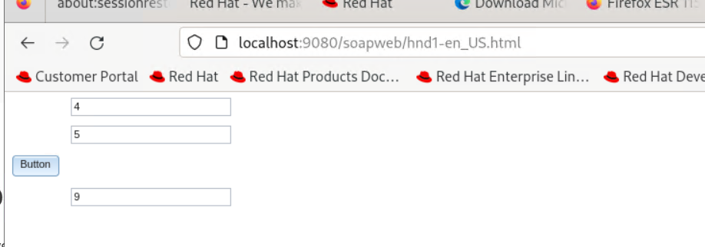

RichUi Deployment:

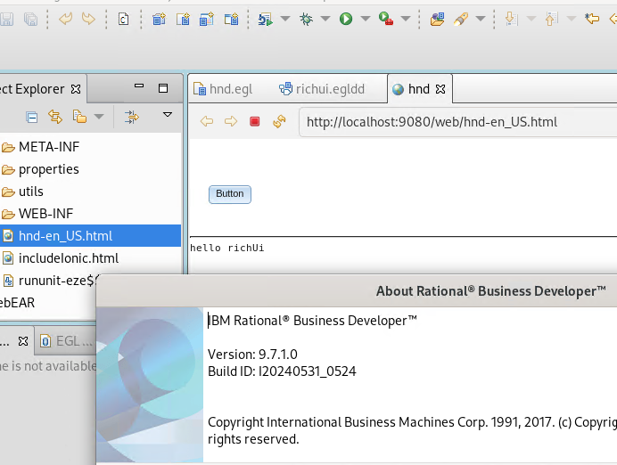

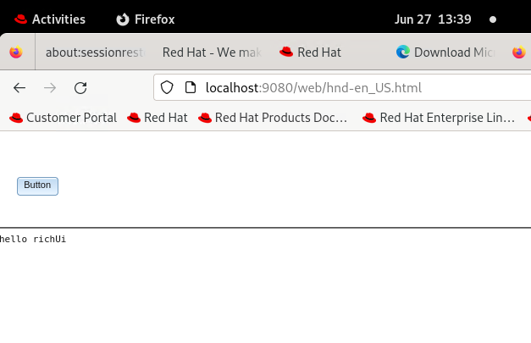

**Tomcat: 9.0.90**

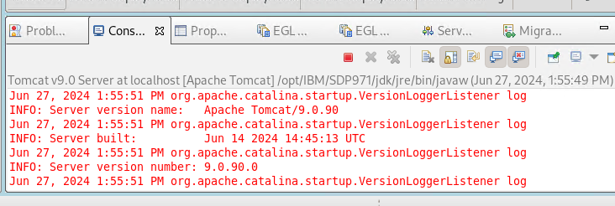

Rest service invocation:

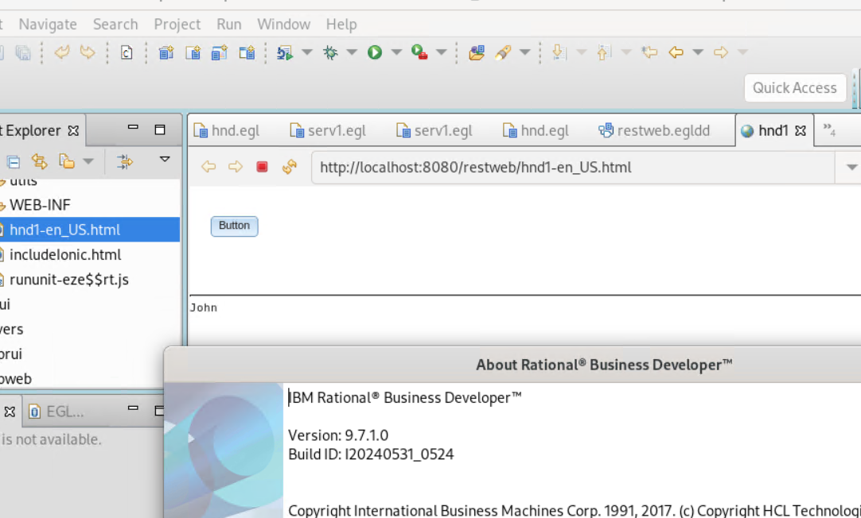

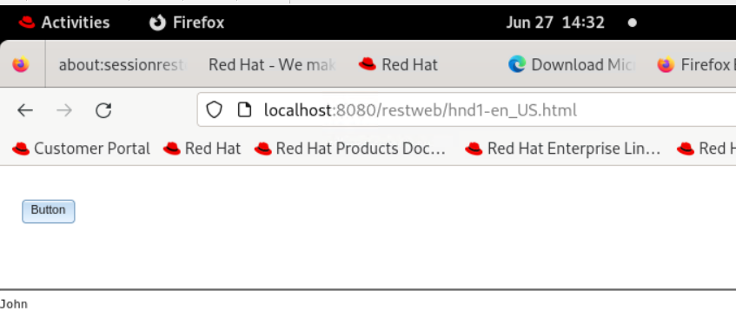

Soap service invocation:

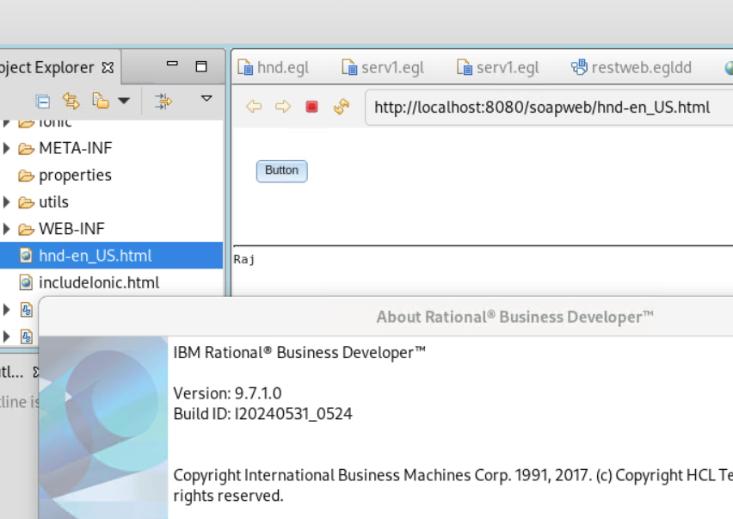

RichUI deployment:

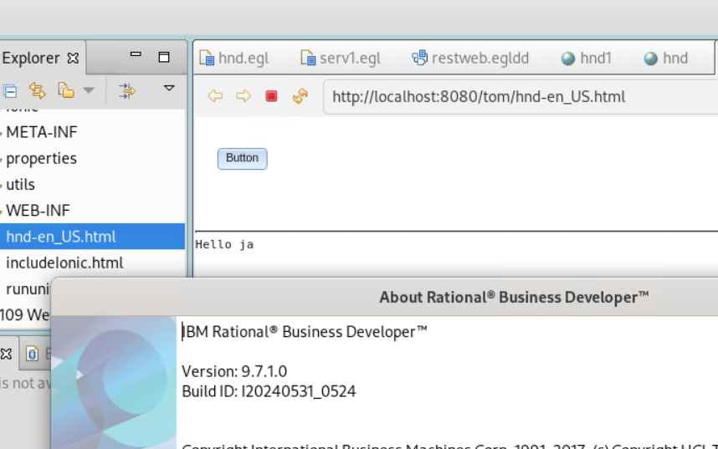

**Liberty 24.0.0.6:**

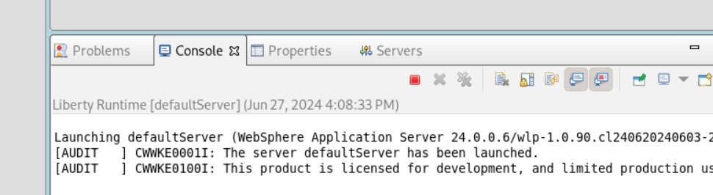

Rest service invocation:

Soap service invocation:

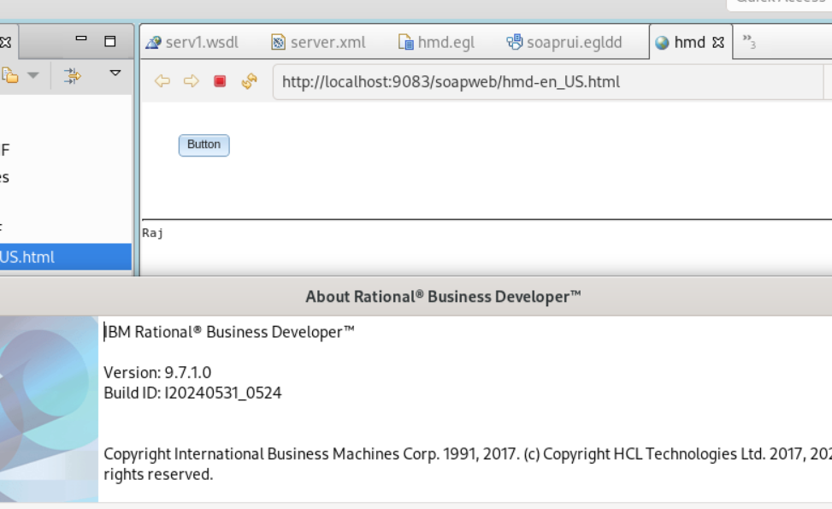

RichUI deployment:

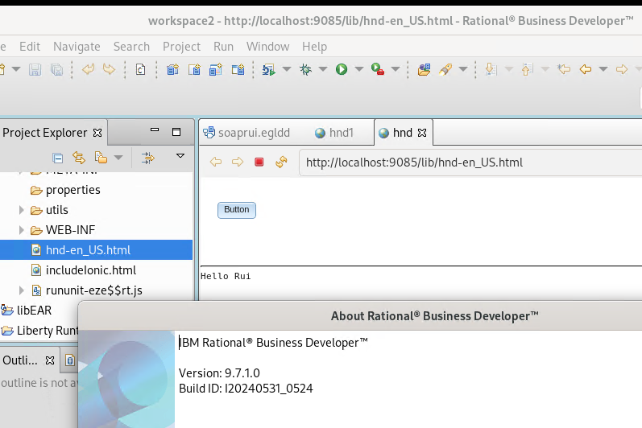

**Final Execution Status:**

|  |  |  |  |  |
| --- | --- | --- | --- | --- |
| **S.No** | **Testing Scenarios** | **Testing Detail** | **Result** | **Comments** |
| 1 | RBD Installation | Installation scenario | Passed |  |
| 2 | Launch RBD | Splash screen | Passed |  |
| 3 | Copy Right year | Installation Directory | Passed |  |
| Splash screen | Passed |  |
| Help Content in RBD | Passed |  |
| Help Content in windows preferences | Passed |
| 4 | What’s New and More  Info | IBM KC | Passed |  |
| What's New in RBD workspace | Passed |  |
| More Info in IBM IM | Passed |  |
| 5 | Readme files | Readme files | Passed |  |
| 6 | Java Project | General project creation (Java) | Passed |  |
| 7 | Rich UI Project | RUI project creation | Passed |  |
| 8 | Web Project | Web project creation | Passed |  |
| 9 | Java Generation | Java Generation | Passed |  |
| 10 | Rich UI Generation with deployment | Firefox web browser | Passed |  |
| Edge browser | Passed |  |
| Chrome browser | Passed |  |
| 11 | SOAP service Invocation | Tomcat Server | Passed |  |
| Liberty Server | Passed |  |
| WAS Server | Passed |  |
| Firefox web browser | Passed |  |
| Edge browser | Passed |  |
| Chrome browser | Passed |  |
| 12 | REST service Invocation | Tomcat Server | Passed |  |
| Liberty Server | Passed |  |
| WAS Server | Passed |  |
| Firefox web browser | Passed |  |
| Edge browser | Passed |  |
| Chrome browser | Passed |  |
| Chrome browser | Passed |  |

Find the Latest Currencies below:

[YBJ QA - Latest 971 currencies - All Documents (sharepoint.com)](https://hclo365.sharepoint.com/sites/YBJQA/Shared%20Documents/Forms/AllItems.aspx?id=%2Fsites%2FYBJQA%2FShared%20Documents%2FRBD%2FRelease%20Work%2F2024%5F971%5FRelease%2FLatest%20971%20currencies&viewid=69430e93%2D1b15%2D4f1a%2Dab9f%2De5cec6096742&noAuthRedirect=1)